WORK 10

***Trending Towards Tapestry / Recent Works* – Haines Brewery exhibit 2022**

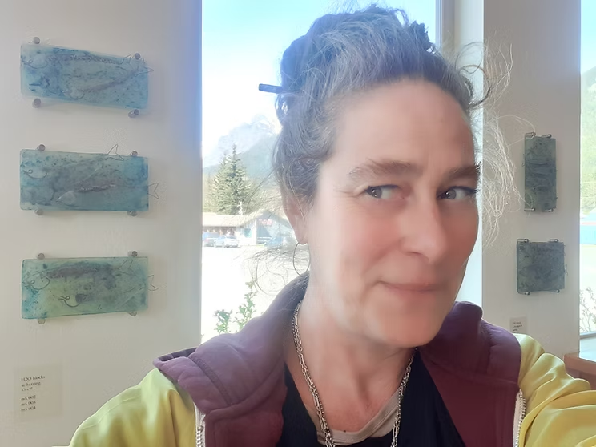

Trending Towards Tapestry is the overarching theme I have been working under the past year – – – – – – –

A theme helps give me focus amongst my various artistic trajectories and tries to stitch the pieces together – –

– – – – Glass Water Blocks – w. Herring & Hooligan – – – –

I’ve been developing some interesting and experimental techniques utilizing metal powders between stacked and kiln fired reclaimed waste sheet glass. The patterns created from the heat, chemical reactions and flow of the glass, become what I’ve been calling “*glass water blocks*.” In a second firing I have been embellishing these H2O blocks with glass hooligan and herring, each fish cut, printed, layered and embellished with copper wire inclusions.

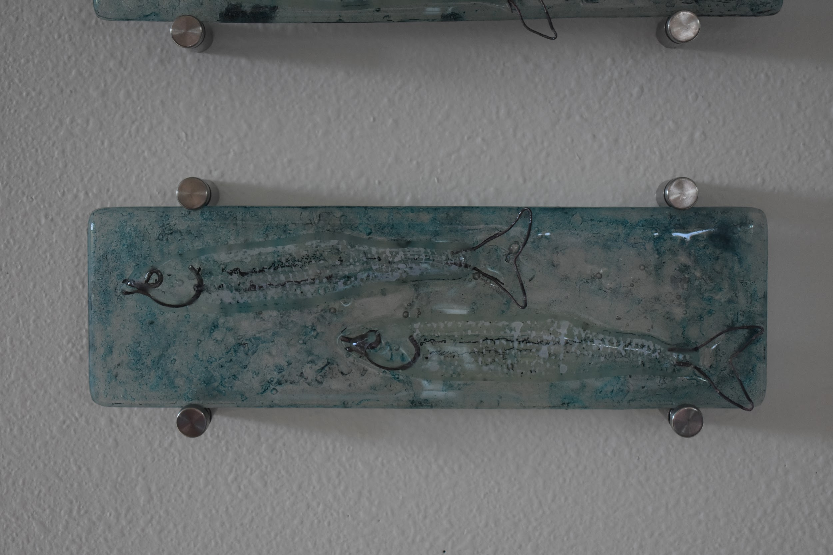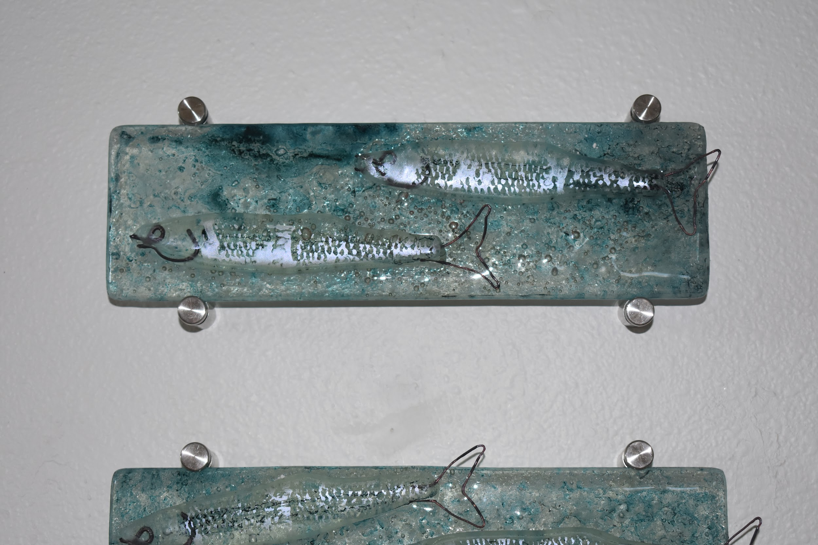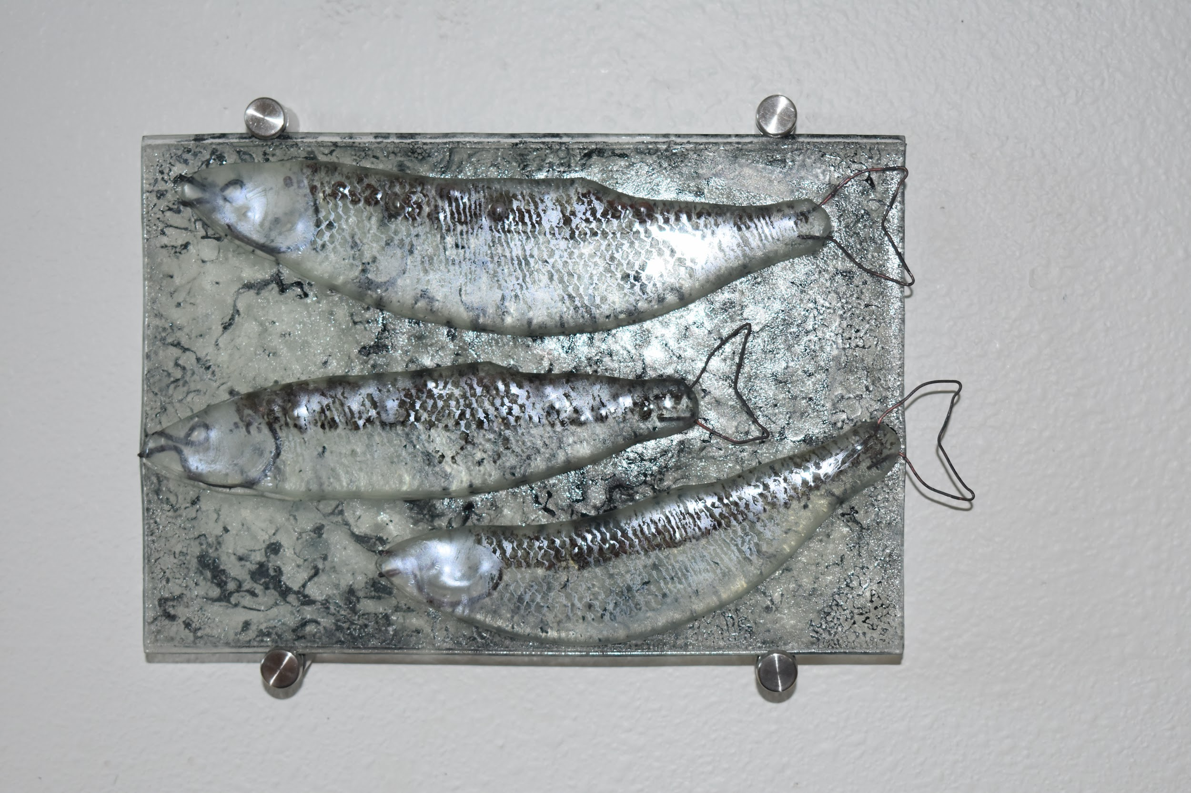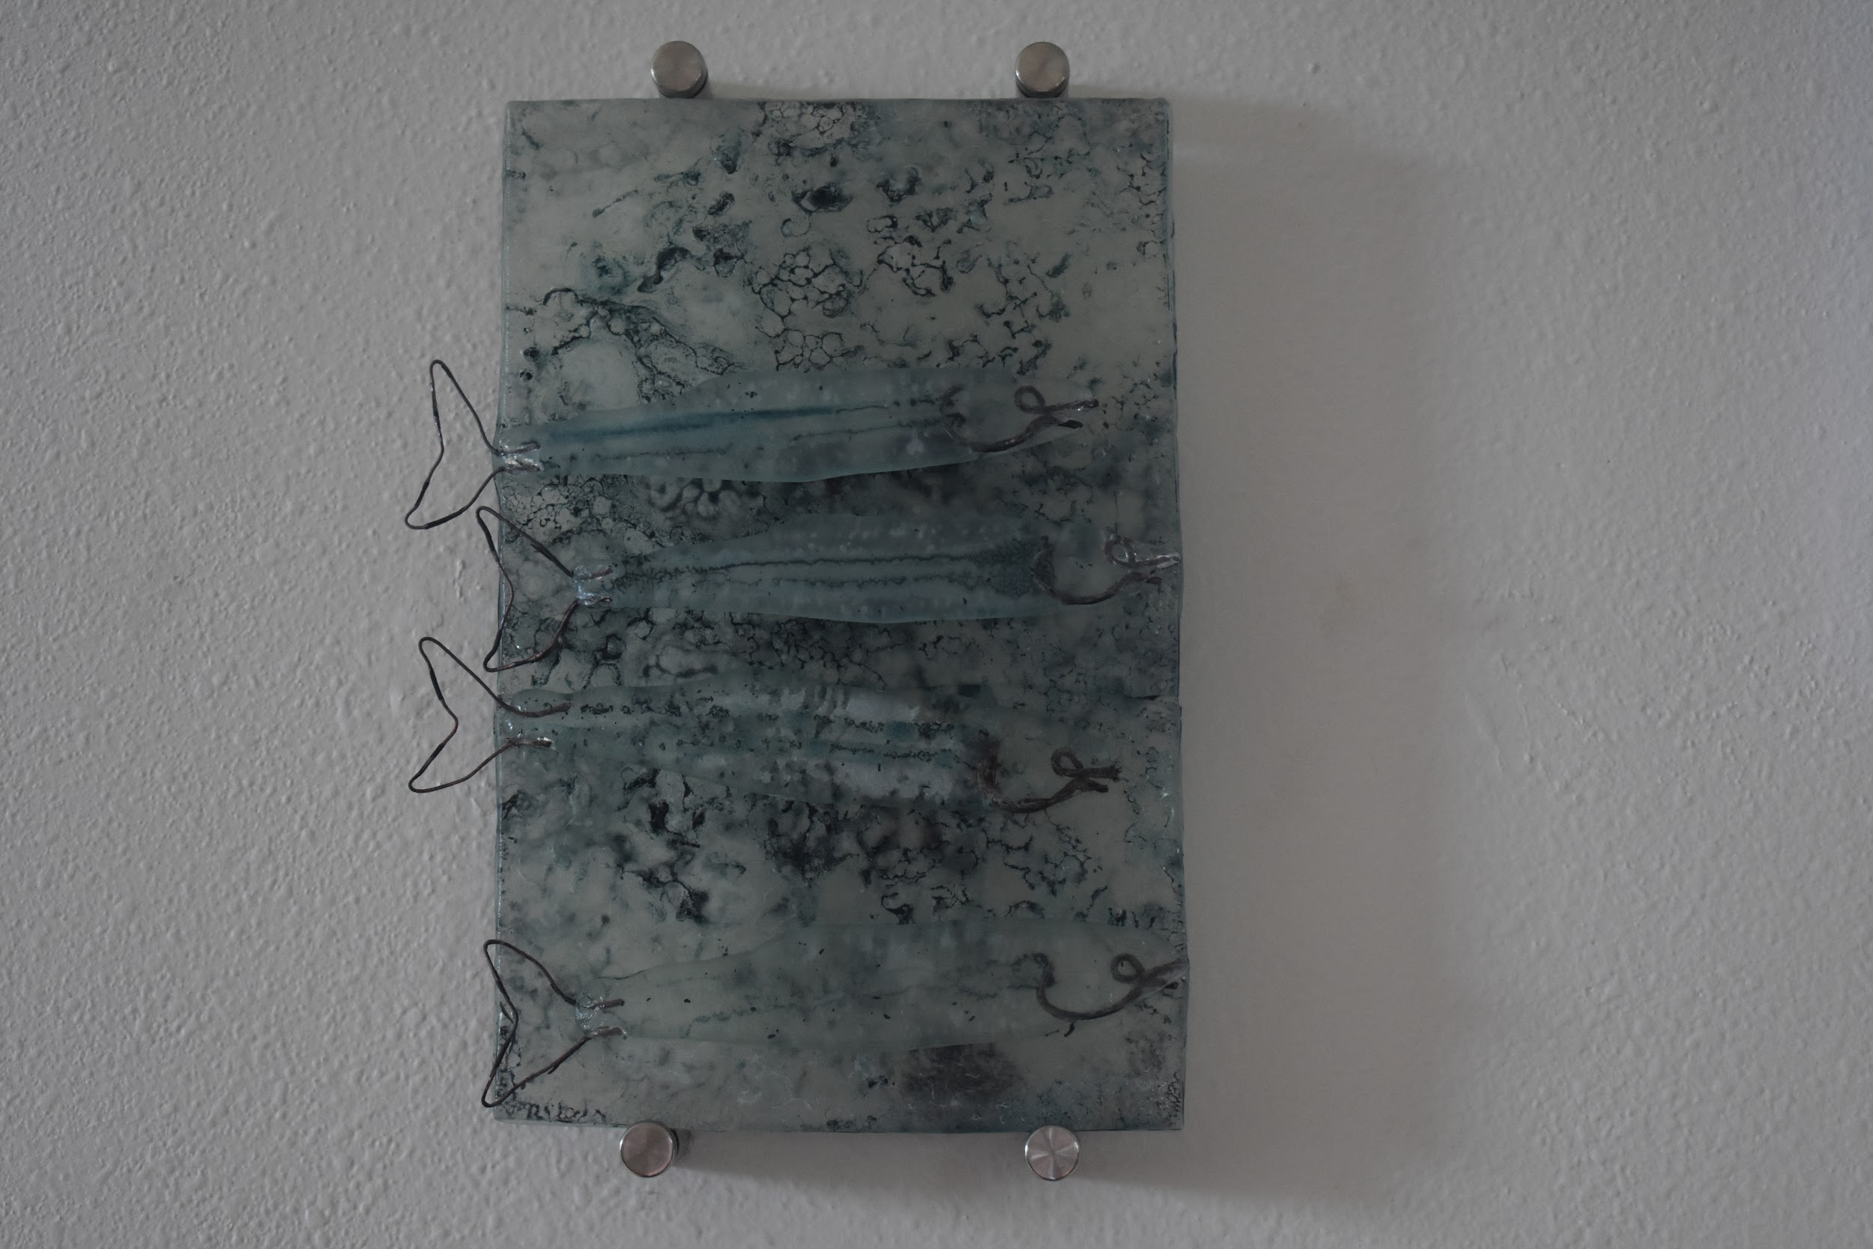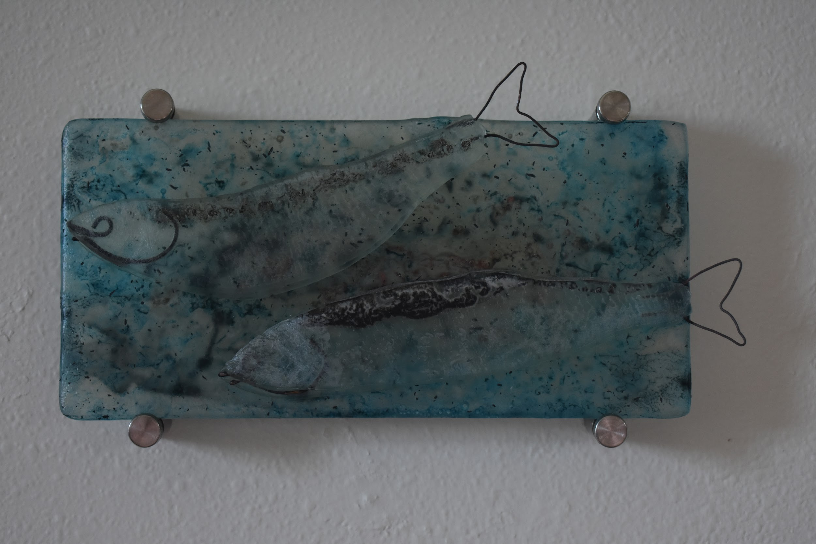

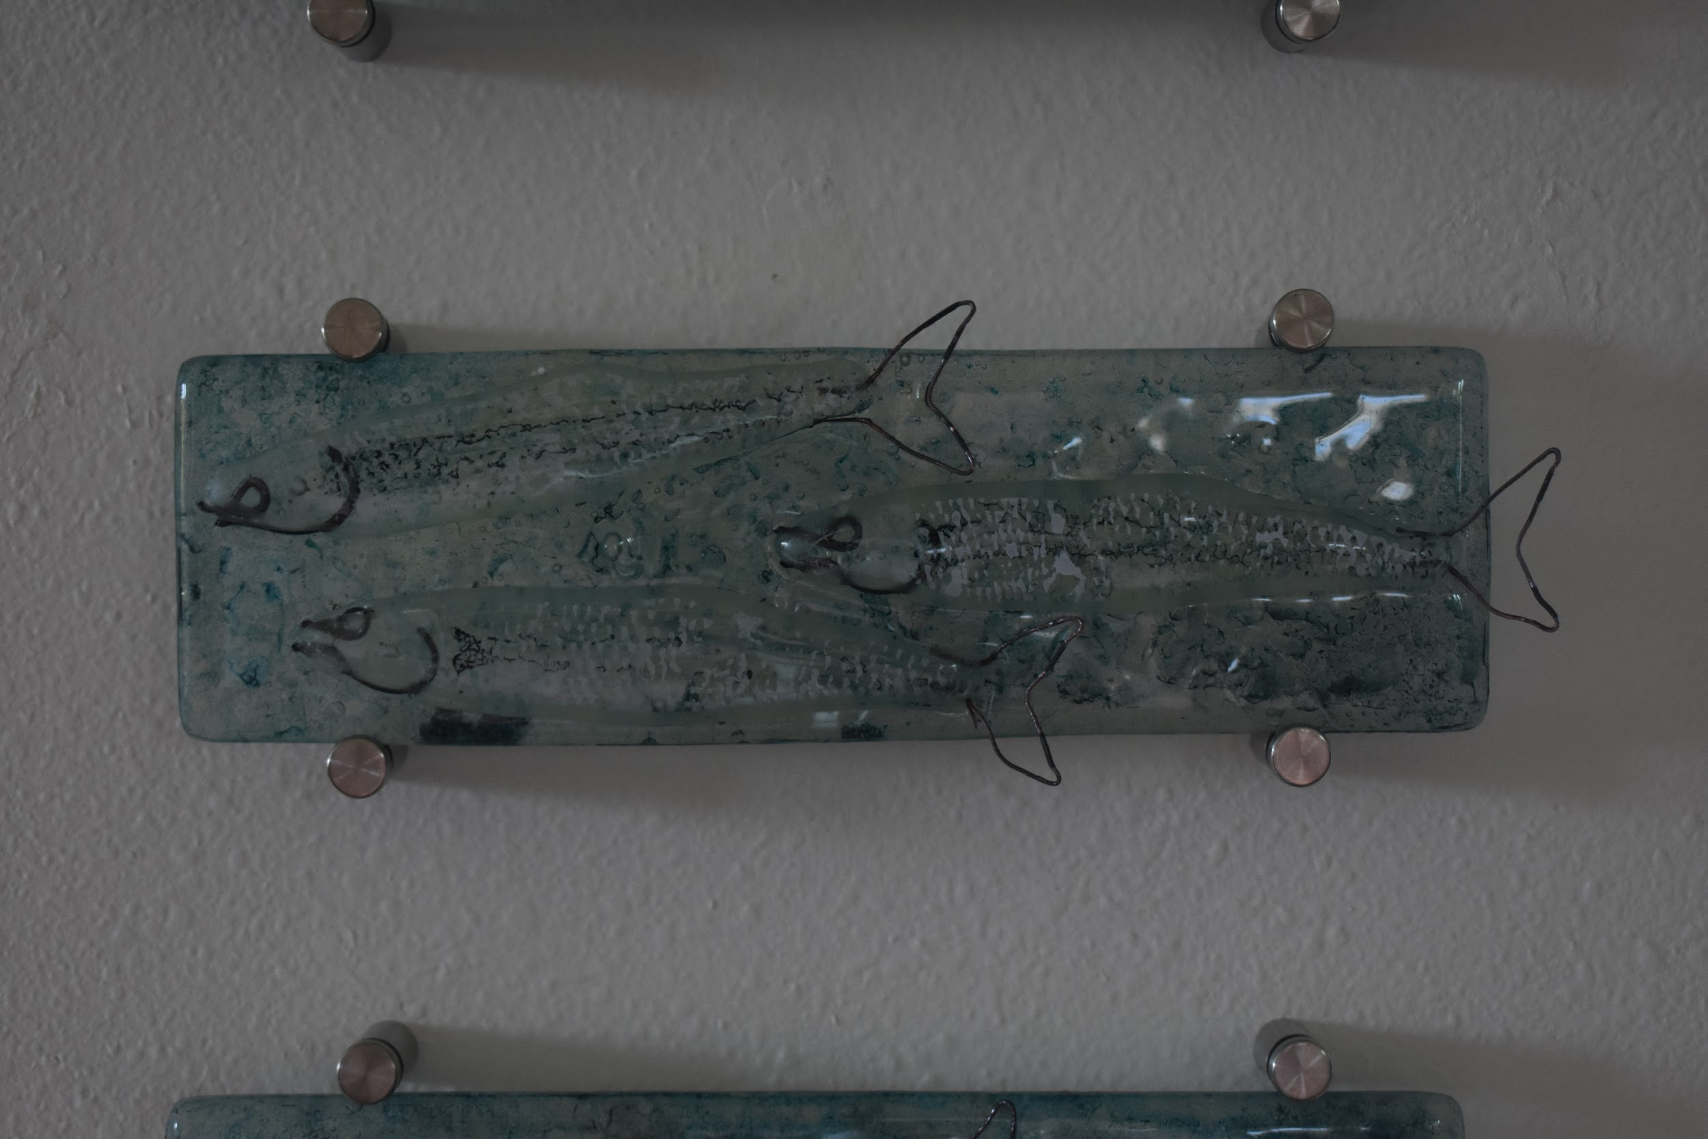– – – – H2O quilts – Boca Water Swatches – – – –

I spent the month of March in Mexico doing something completely foreign to my artistic experience; I worked as a studio assistant at Casa de los Artistas for a series of plein air artists and teachers who specialized in oil paintings of atmosphere, palette knife and color landscapes, respectively. After looking at shapes, shadows and the water for weeks on end, I had an epiphany.

I realized I’m not a plein air painter.

I also realized I can paint my own thing, In this case “*the essence of water”* — embellished with the small pieces of plastic which came to me at the shore of la playa. 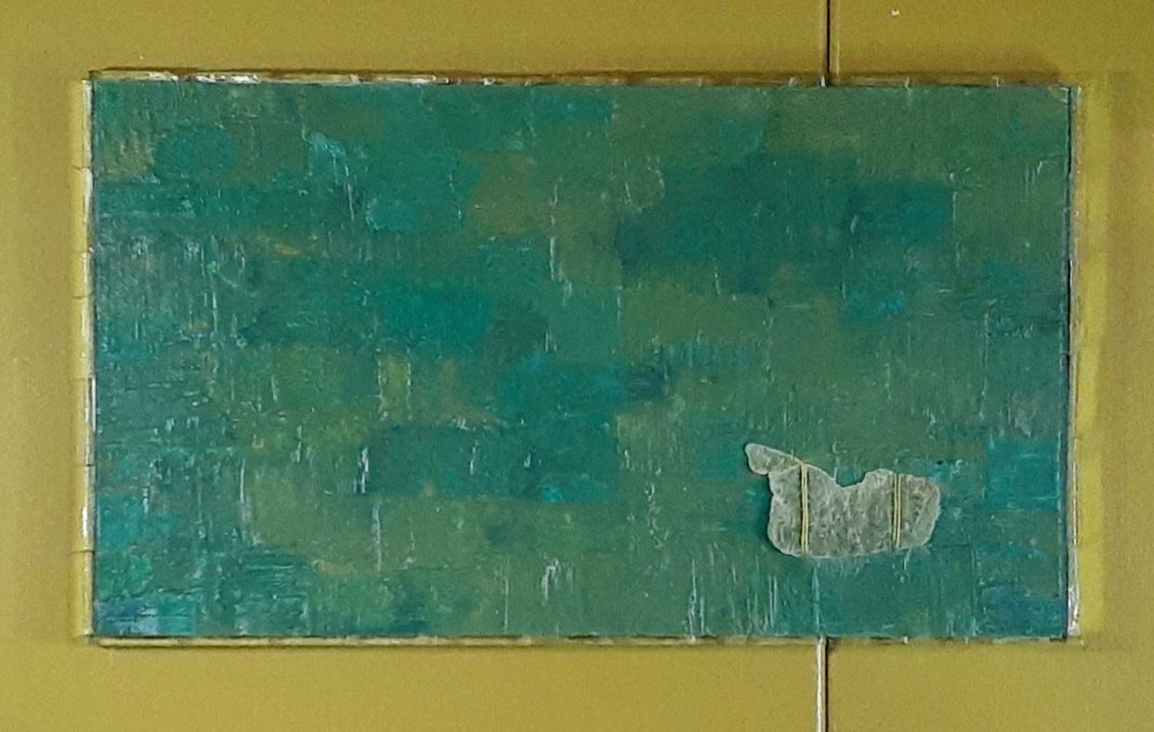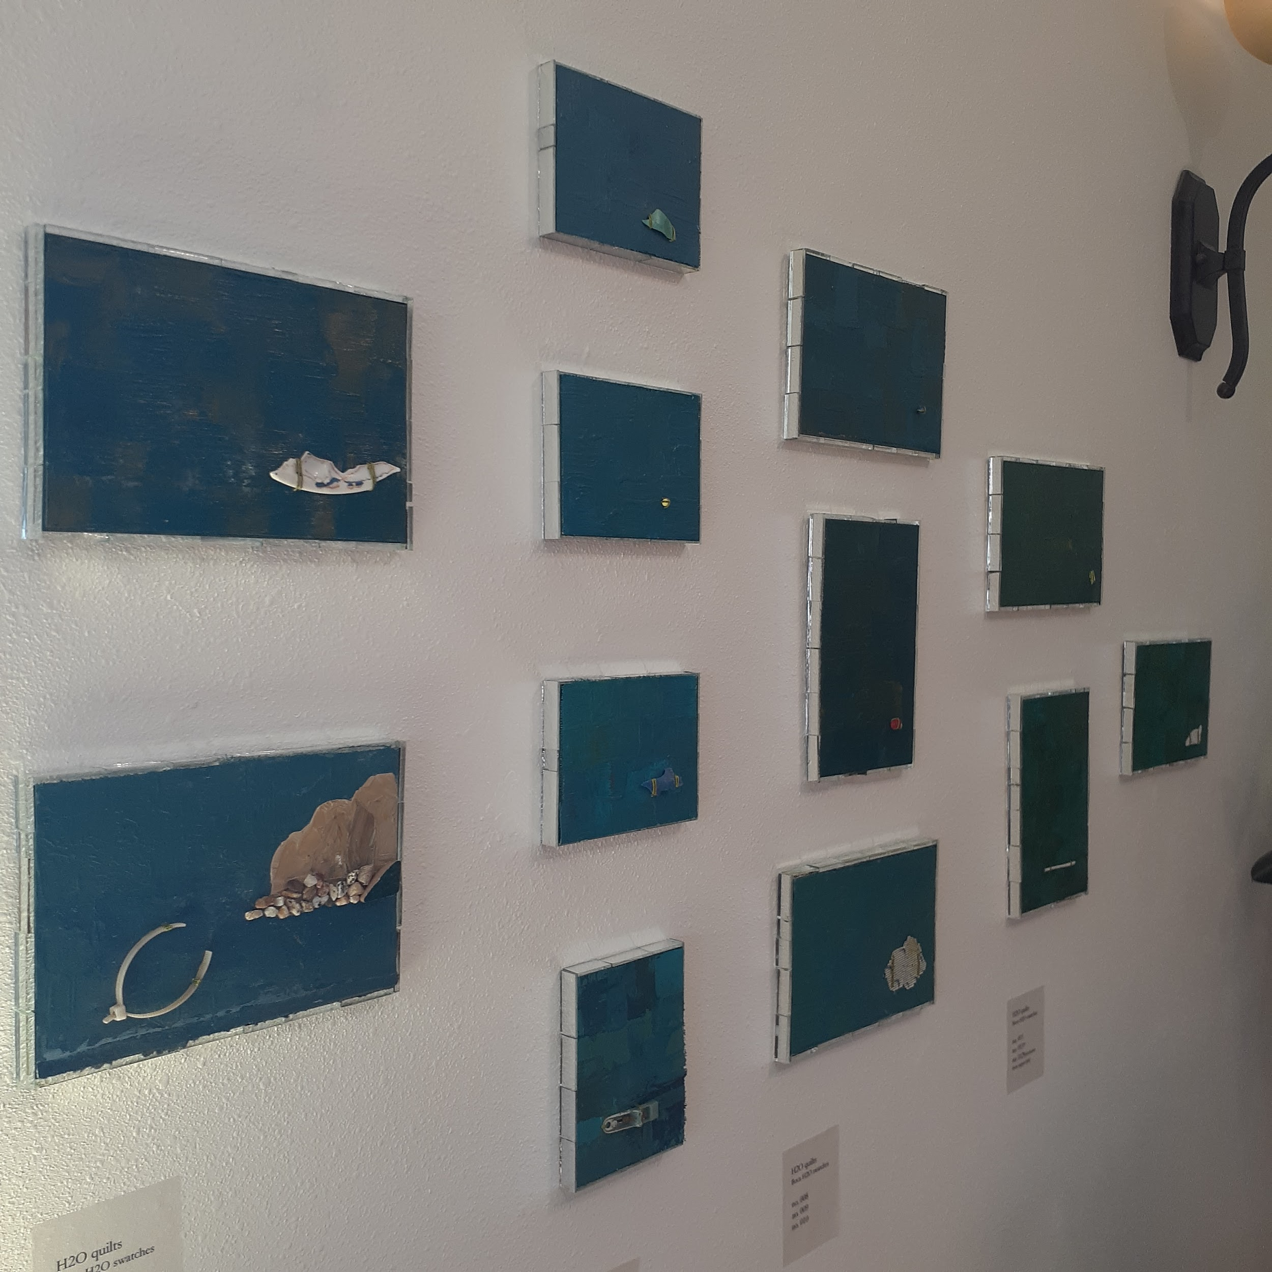

– – – – H2O quilts – w. Flying Hooligan – – – –

When I first started painting the water paintings / H2O quilts I had the idea of using them for backgrounds for my new series of flying hooligans — and so this series took form —

I’ve been thinking of how to incorporate plastics (successfully) with my glassworks for some time. And have been dreaming of flying fish – – – –

I figured that Hooligan – the fish I make specifically for Haines – would be a good place to start! 